DIRECTLY ANSWERED QUESTION
SKILL 3 : ANSWER STATED DETAIL QUESTIONS CIRRECTLY

A stated detail question maksudnya adalah pertanyaan-perntanyaan yang meminta pembaca untuk mencari informasi spesifik yang ada didalam teks. Jawaban dari pertanyaan ini tidak selalu persis sama dengan kalimat-kalimat didalam teks tetapi bisa saja merupakan ”restatement.” ”restatment” adalah formulasi kalimat berbeda tetapi idenya tetap sama. Contohnya :
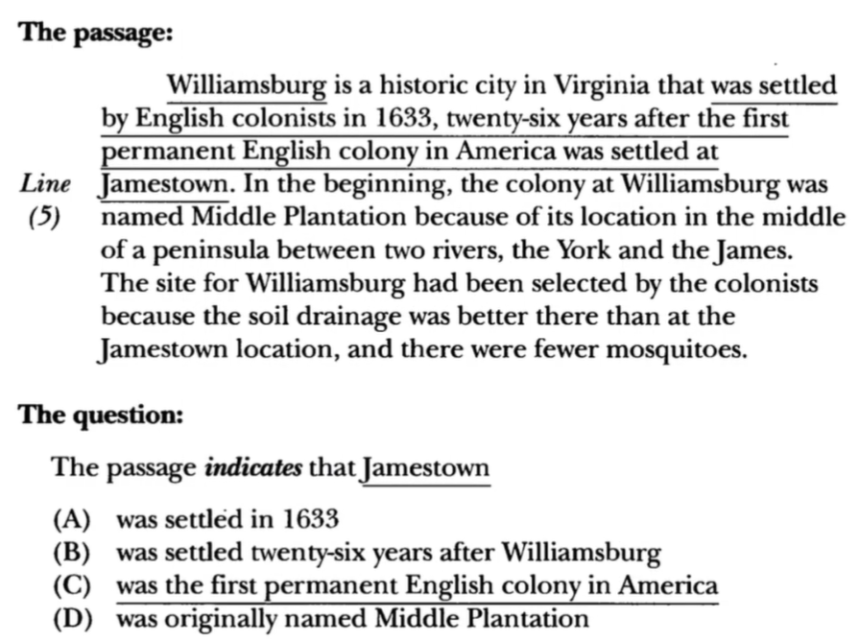
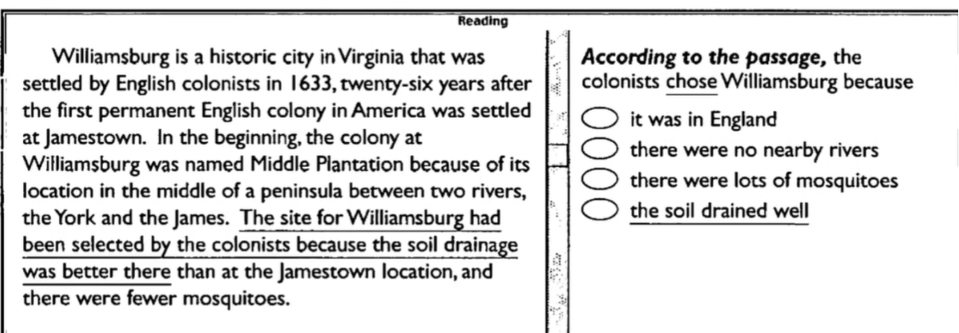

KESIMPULAN
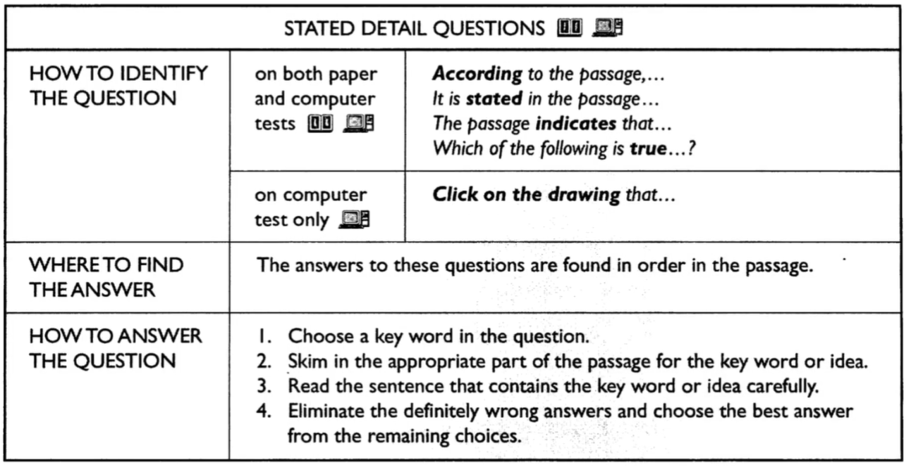

LATIHAN
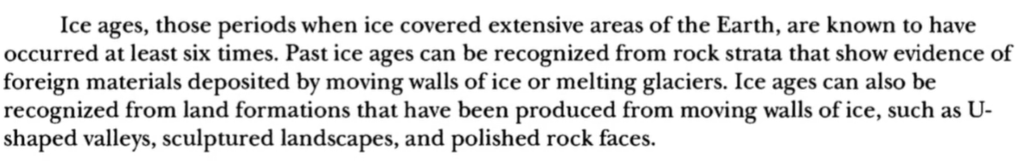

- According to the passage, what happens during an ice age?
- Rock strata are recognized by geologist
- Evidence of foreign materials is found
- Ice covers a large portion of the Earth’s surface
- Ice melts six times
- The passage covers how many different methods of recognizing past ice ages?
- One C. Three
- Two D. Four
- According to the passage, what in the rock strata is a clue to geologists of a past ice age?
- Ice
- Melting glaciers
- U-shaped valleys
- Substances from other areas
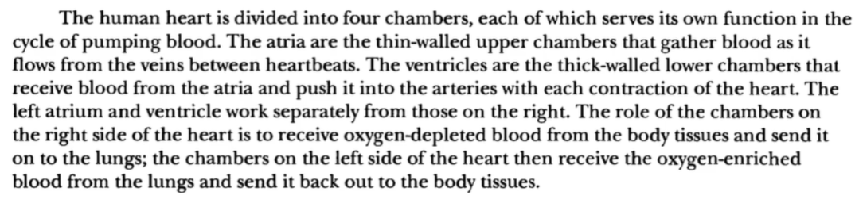
- The passage indicates that the ventricles?
- Have relatively thin walls
- Send blood to the atria
- Are above the atria
- Force blood into the arteries
- According to the passage, when is blood pushed into the arteries from the ventricles?
- As the heart beats
- Between heartbeats
- Before each contraction of the heart
- Before it is received by the atria
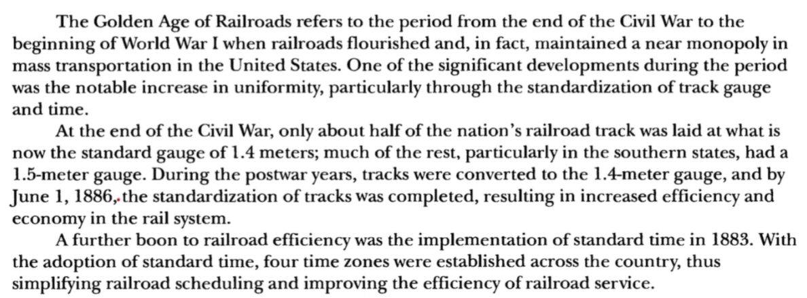
- According to the passage, the Golden Age of Railroads
- Was a result of world war I
- Was a period when most of U.S. mass transportation was controlled by the railroads
- Resulted in a decrease in uniformity of track gauge
- Resulted in standardization of train stations
- The passage mentions that which of the following occurred as a result of uniformity of track gauge?
- The civil war
- Improved economy in the transportation system
- Standardization of time zones
- Railroad schedules
- The passage indicates that standard time was implemented
- Before the civil war
- On June 1, 1886
- After World War I
- Before standardized track gauge was established throughout the United States

SKILL 4 : “UNSTATED” DETAIL QUESTIONS

Terkadang didalam test anda akan ditanya tentang pertanyaan yang jawabannya tidak tercantum, tidak disebutkan ataupun tidak benar. Apabila ada pertanyaan seperti ini berarti akan ada 3 jawaban benar dan 1 jawaban salah atau tidak dicantumkan atau disebutkan dalam teks.
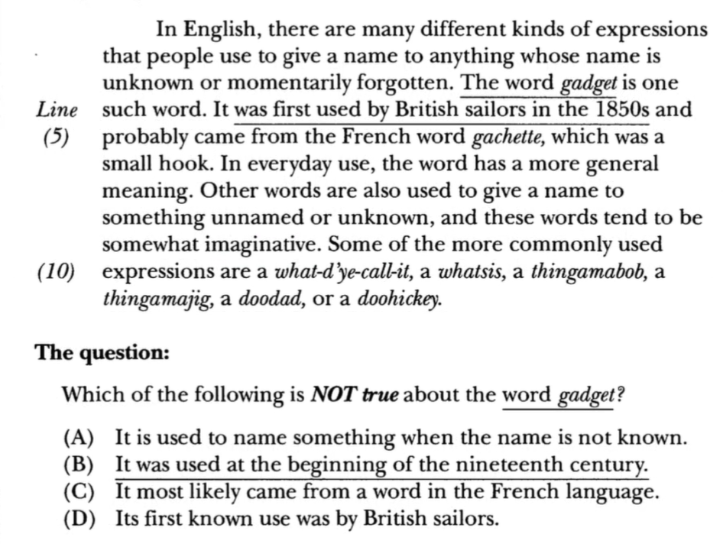
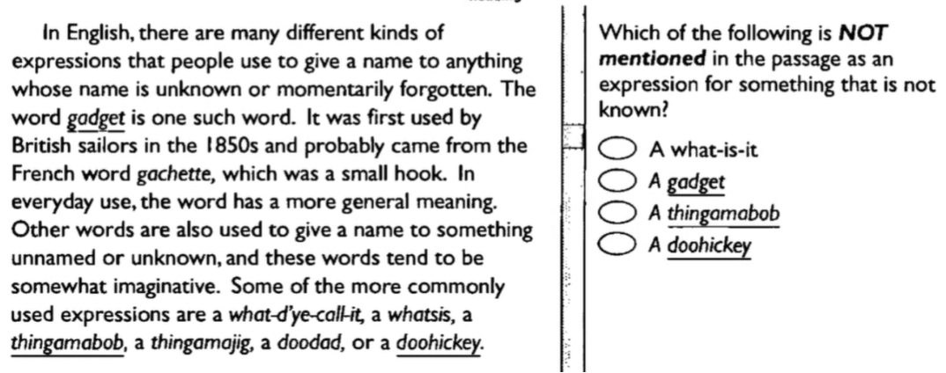

KESIMPULAN
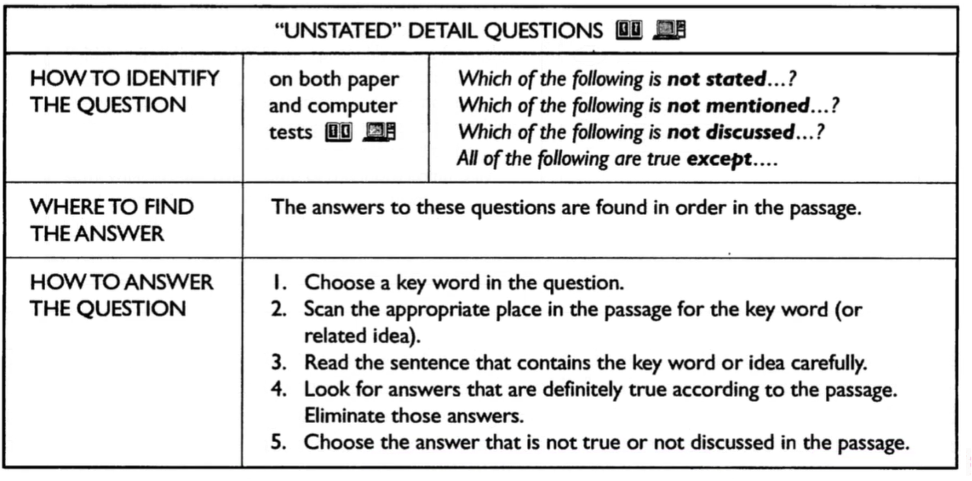

LATIHAN
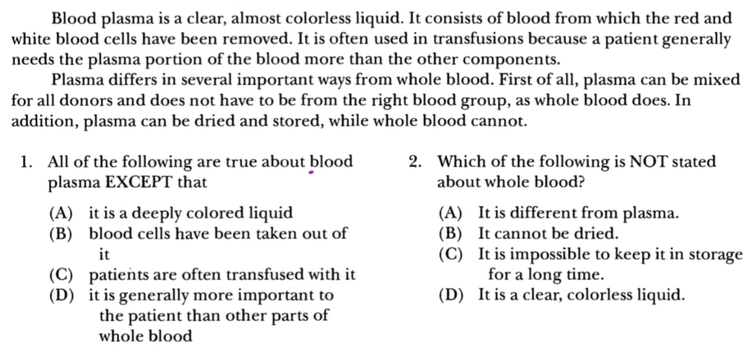
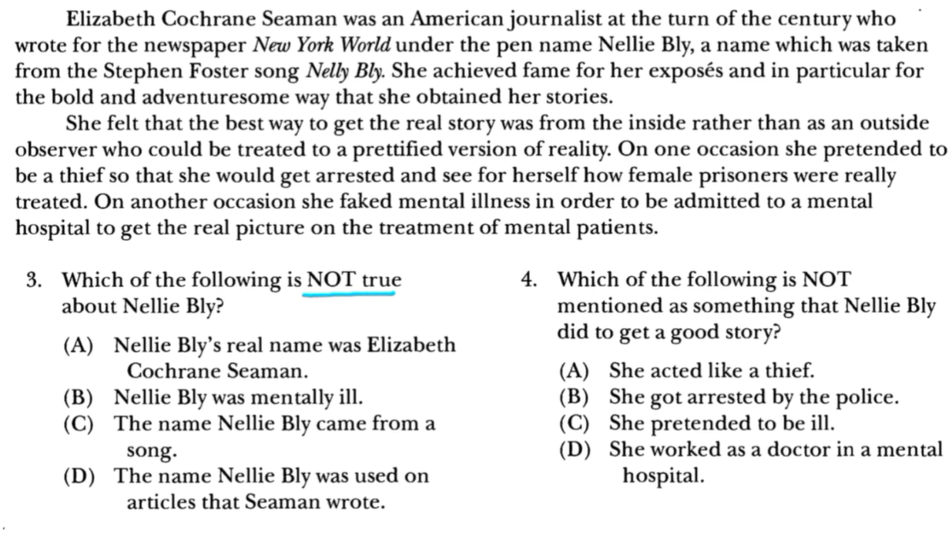
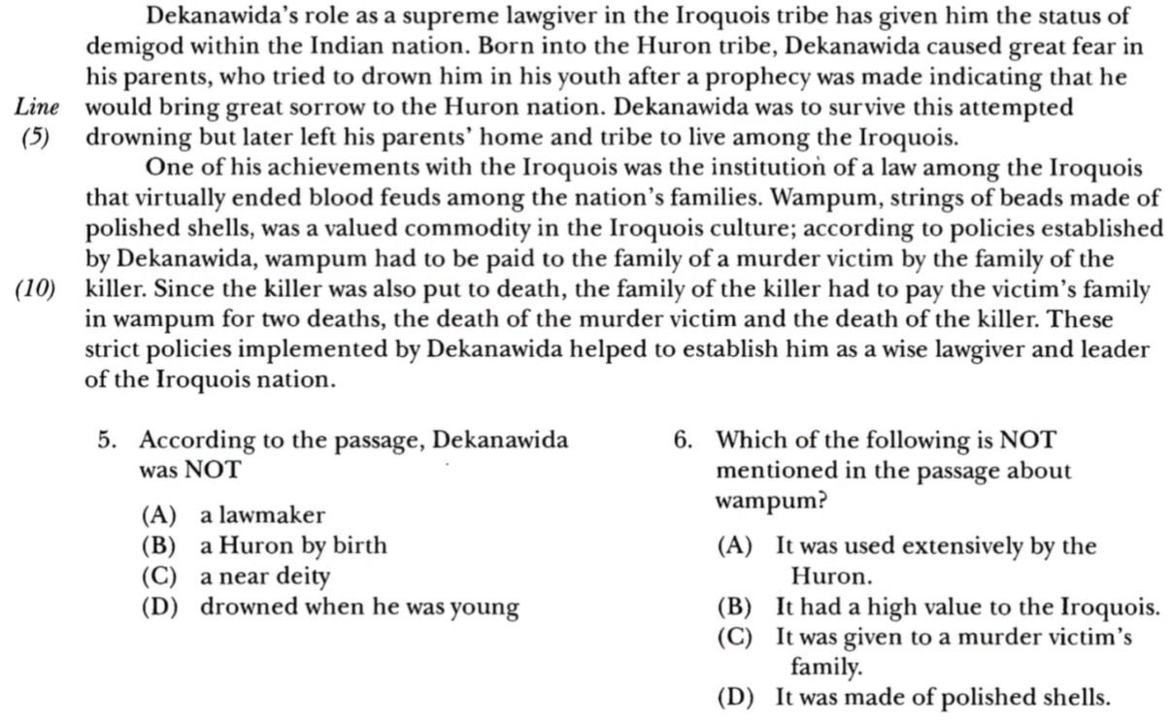

SKILL 5 : PRONOUN REFERENCE QUESTIONS

Didalam test anda akan ditanyakan tentang rujukan kata dari sebuah kata yang dimaksud didalam teks. Untuk menjawab pertanyaan tersebut maka anda dapat mencari katanya ‘sebelum’ rujukan kalimatnya.
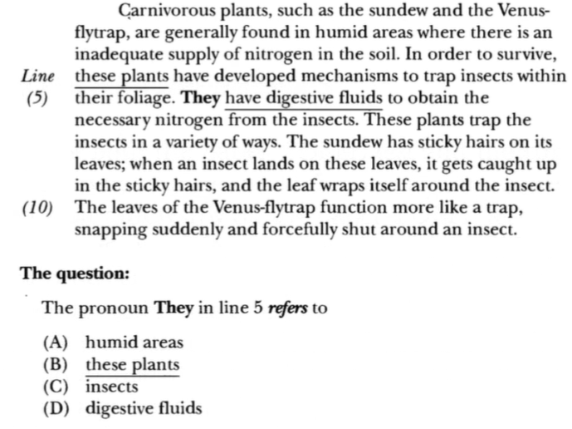

KESIMPULAN
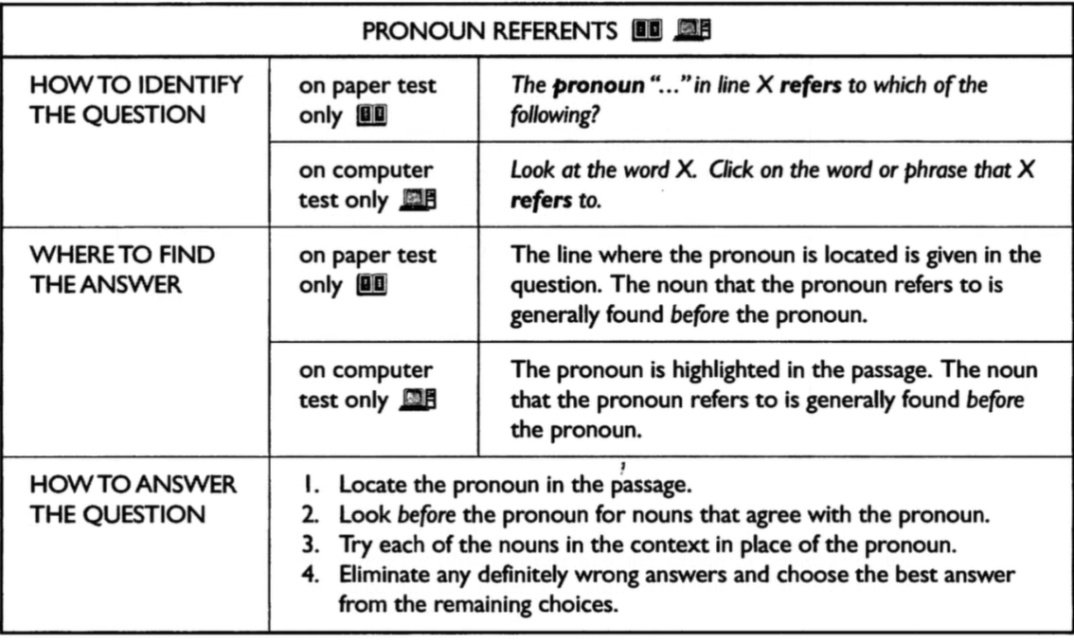
LATIHAN
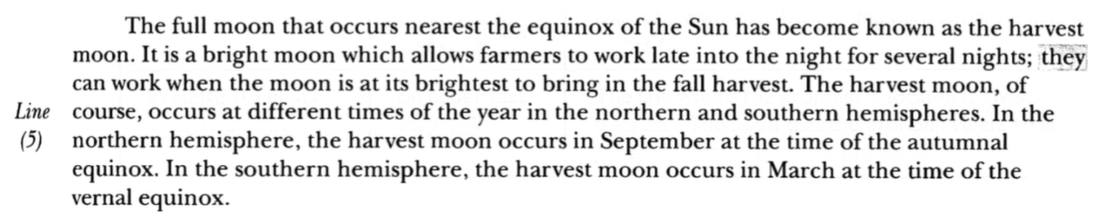
- The pronoun ‘it’ in line 2 refers to …
- The equinox
- The sun
- The harvest moon
- The night
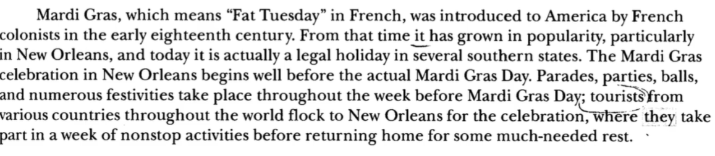
- The pronoun ‘it’ in line 2 refers to …
- Mardi Gras C. That time
- French D. New Orleans
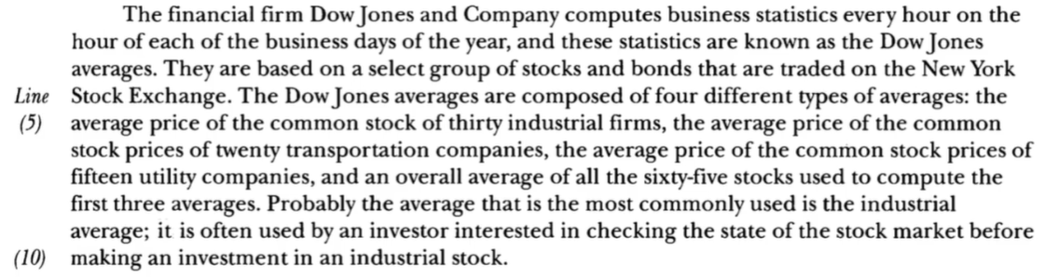
- The pronoun ‘they’ in line 3 refers to …
- The business day C. Stocks and bonds
- These statistics D. Four different types

EVALUASI SKILL 3-5
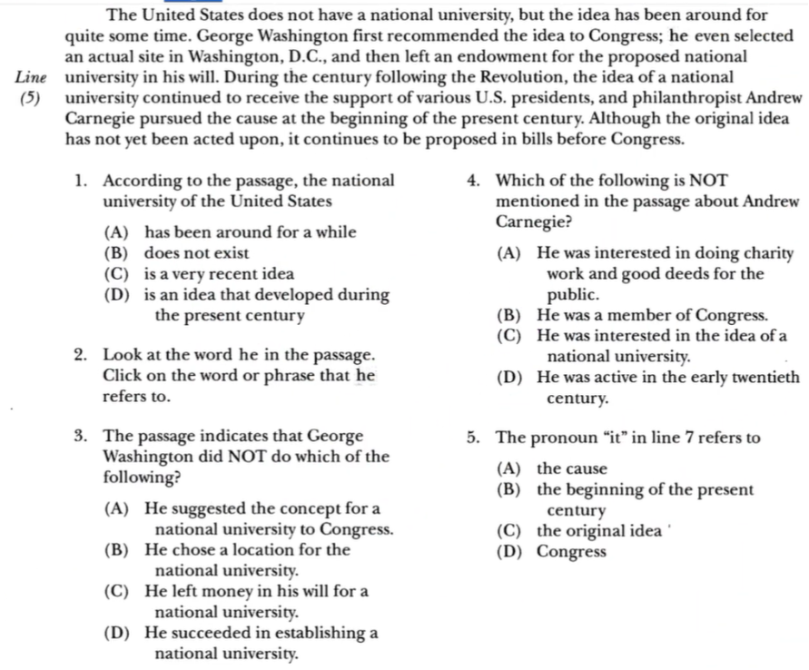
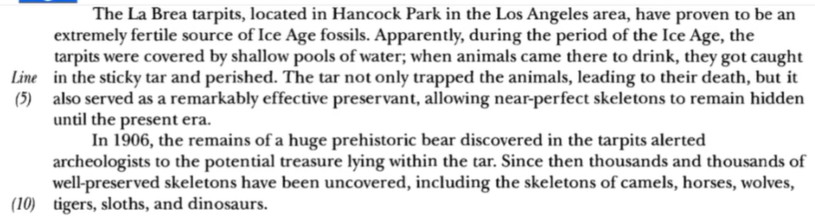
- Which of the following is NOT true about the La Brea tarpits?
- They contain fossils that are quite old
- They are found in Hancock Park
- They have existed since the ice age
- They are located under a swimming pool
- The pronoun ‘they’ in line 3 refers to
- The La Brea tarpits
- Ice age fossils
- Shallow pools of water
- Animals
- When did archaeologists become aware of the possible value of the contents of the tarpits?
- During the ice age
- Thousands and thousands of years ago
- Early in the twentieth century
- Within the past decade
- Which of the following is NOT mentioned as an example of a skeleton found in the tarpits?
- A bear C. A horse
- A sloth D. A snake
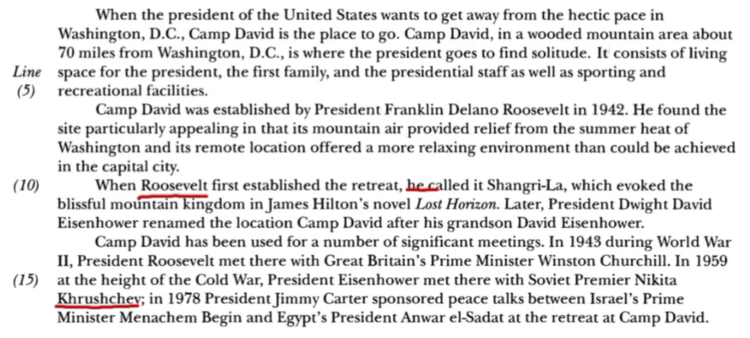
- Which of the following is NOT discussed about camp David?
- Its location C. Its facilities
- Its cost D. Its uses
- According to the passage, who founded camp David?
- George Washington
- The first family
- Franklin Delano Roosevelt
- Dwight David Eisenhower
- The pronoun ‘he’ in line 10 refers to?
- Camp David C. James Hilton
- Roosevelt D. President Dwight David Eisenhower
- Which of the following is NOT true about President Eisenhower?
- He had a grandson named David
- He attended a conference with Nikita Khrushchev
- He named the presidential retreat Shangri-La
- He visited Camp David
- Khrushchev was a at camp David in
- 1942 C. 1959
- 1943 D. 1978

